1. Explain : The EXPLAIN statement in MYSQL is used to analyze and understand how a query will be executed.

Column of EXPLAIN
a. id : It is a identifier of the query

Possible values: Sequential Integer
if 1 is the value that means the query do not performed subqueries and unions

b. select_type: it tell us about type of select query

Possible values:
Simple : No subqueries or unions.

Primary: Outmost select type.

Union: second or later select statement in a Union.

Dependent Union: second or later select statement in a union dependent on outer query.

Subquery: First Select in subquery.

Dependent Subquery: First Select in subquery dependent on outer query.

Derived: Derived Table.

Dependent Derived: Derived Table dependent on another table.

Materialized: Materialized Subquery.

Uncacheable Subquery: A subquery for which the result cannot be cached and must be re evaluated for each row of outer query.

Uncacheable Union: The second or later select in union that belong to an uncacheable subquery.

c. Table: The name of the table or the alias given to the table name.

d. partitions: List the partitions accessed if the table is partitioned . Partition name or Null if no Partitions are involved.

e. type: The join type or access method for the table

Possible values:

system: Table with only one row.

const: At most one matching row.

eq_ref: matches one row per combination of column.

ref: matches multiple row using an index.
ref_or_null: Similar to ref with additional advantage of extra search for rows that contain Null values.

index_merge: This join type indicates that the Index Merge optimization is used. In this case, the key column in the output row contains a list of indexes used, and key_len contains a list of the longest key parts for the indexes used.

range: index range scan.

index: full index scan.

ALL : full table scan.

f. possible key: List of index that might be used for this table. Possible values can be name of index or null.

g. key: actual index that is used to return query . Possible value name of index or null.

h. key_length: The length of index used to return the result. Possible value will be length of index

i. ref: the column used to match row b/w two table when foreign key is used . Possible value name of column or Null.

j. rows: Number of row mysql plan to examine in order to execute the query.Possible value is the number of row scanned.

k. filtered: indicate an estimated percentage of table rows that are filtered by table condition.Values can be b/w 0 to 100.

l. extra: Additonal information about query.
Possible value:-
Using where: A WHERE condition is applied
Using index: Only index is used
Using temporary:A temporary table is used
Using filesort: A sort operation is performed that isn’t index based.
Range checked for each record: indexes are checked for each row.

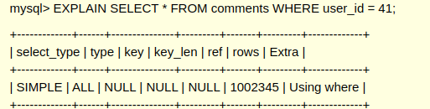
2.

As the query output this table it has some meaning they are as follows:
select_type: ‘SIMPLE’mean that the no subqueries or union is perfomed/executed to get the result set.
Type: ‘ALL’ mean that Full Table Scan is performed to get the result set.
Key: no index is used .
key_len: no index then no index length.
Ref: no other table is referred to get the result set.
Rows: ‘1002345’ mean total this no.of row mysql plan to examine to get the result.
Extra: ‘Using WHERE’ where clause is used to get the result.

2.1. It means that the query has performed examination on the whole table/row to get the answer .Moreover indexing is not used to speed the search.

2.2. No this is not the optimal query as type column is All this mean full table is scanned to get the result .To optimize the query we need to create index based on user_id to get fast retrieval of the result

Create index idx_user_id on comments(user_id);

3.
3.1 we can make a composite index of column {commentable_type and user_id}
or combination of { commentable_type and user_id and commentable_id

4.
4.1
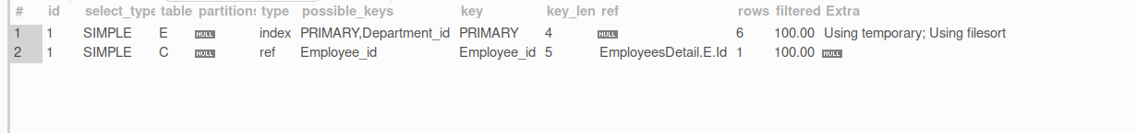
id: 1 indicate that no subquery is used
select_type: it tell type of select query is used here it is simple means no subquery and unions are used.
Table: it is the name of table used in query and E,C are the alias given to table
partition: no partition is used in query so the table is Null
type: in the first table full index scan is performed and in second table reference column is used to match multiple row
possible key: primary,department_id are possible key in first table that can be used and Employee_id is the only possible key to used for search for second table.
Key:Primary key is used for for searching in first table and Employee_id in second table
Key_len: Primary key of table one is of int type the key length is 4 and 5 is for employee_idas 1 bit extra for referencig.
Ref:no reference is made by table one and second table is referred using EmployeesDetail.E.id
Rows: 6 row were examine in table one and 1 row is examine in table 2
filtered : indicate 100% row are filtered
extra: table one uses temporary,filesort to get the result

No, we got two row in output

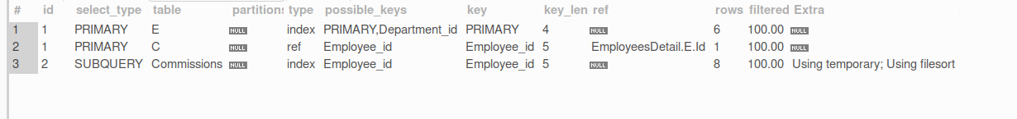
4.2

id: 1 indicate that no subquery is used and 2 indicate that subquery or union is used

select_type: it tell type of select query is used here it is ‘simple’ for two table means no subquery and unions are used and subquery for one table means subquery is used

Table: it is the name of table used in query and E,Care the alias given to table and Commissions is the table name

partition: no partition is used in query so the table is Null

type: In the first and third table full index scan is performed and in second table reference column is used to match multiple row

possible key: primary,department_id are possible key in first table that can be used and Employee_id is the only possible key to used for search for second and third table

Key:Primary key is used for for searching in first table and Employee_id in second and third table

Key_len: Primary key of table one is of int type the key length is 4 and 5 is for second and third table as 1 bit extra for referencig.
Rows: 6 row were examine in table one and 1 row is examine in table 2 and 8 in third table
filtered : indicate 100% row are filtered
extra: table third uses temporary,filesort to get the result

The query with join is better than subquery as more row are examined in subquery

